THIS IS THE TITLE OF THE CONTRIBUTION IN
TIMES 12 BOLD CENTERED

A. Author1,‡ B. Author2,‡ C. Author3†

‡Department, Address, Country(Times 10)
†Department, Address, Country(Times 10)
E-mail: your.address@here.it (Times 10)

This is the text of your one-page abstract. Please use Times 12 and leave margins of 3 cm all around. Do not indent the paragraphs. Indicate your references in the text as shown here [1]. This is another citation [2]. Show only one or two black and white or grey-scale images and number them progressively with arabic numbers (e.g., see Fig. 1).

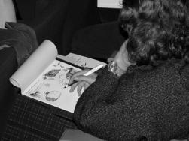
Fig. 1. A Brixen2003 participant taking notes during a lecture (Times 10 here).

Do not add page numbers. Send the abstract via e-mail to the congress address. Thank you!

References (Times 12 here and Times 10 each reference)

[1] E. M. Purcell, R. V. Pound, and N. Bloembergen Phys. Rev. 70, 986-987 (1946)
[2] E. Hahn Phys. Rev. 80, 580-594 (1950)

