THIS IS THE TITLE OF THE CONTRIBUTION IN
TIMES 12 BOLD CENTERED

A. Author1,‡ B. Author2,‡ C. Author3†

‡Department, Address, Country(Times 10)
†Department, Address, Country(Times 10)
E-mail: your.address@here.it (Times 10)

Keywords: (please select in this list the keywords suitable for your contribution and delete the unselected ones):
solid state NMR, solution NMR, low field NMR, MRI, hyperpolarization, materials, small molecules, biomolecules, metabolomics, food, polymers, contrast agents, theory and methods, instrumentation, exotica.

This is the text of your one-page abstract. Please use Times 12 and leave margins of 3 cm all around. Do not indent the paragraphs. Indicate your references in the text as shown here [1]. This is another citation [2]. Show only one or two black and white or grey-scale images and number them progressively with arabic numbers (e.g., see Fig. 1).

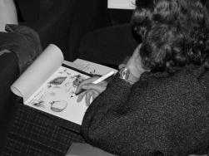
Fig. 1. A Brixen2003 participant taking notes during a lecture (Times 10 here).

Do not add page numbers. Send the abstract via e-mail to roma2023@gidrm.org. Thank you!

References (Times 12 here and Times 10 each reference)

[1] E. M. Purcell, R. V. Pound, and N. Bloembergen Phys. Rev. 70, 986-987 (1946)
[2] E. Hahn Phys. Rev. 80, 580-594 (1950)

