**THIS IS THE TITLE OF THE CONTRIBUTION IN**

**TIMES 12 BOLD CENTERED**

A. Author1,a B. Author2,b C. Author3c

aInstitution, Address, Country

bInstitution, Address, Country

E-mail: [your.address@here.it](mailto:your.address@here.it)

This is the text of your one-page abstract. Please use Times 12 and leave margins of 2 cm all around. Do not indent the paragraphs. Indicate your references in the text as shown here [1]. This is another citation [2]. Show only one or two images and number them progressively with arabic numbers (e.g., see Fig. 1).

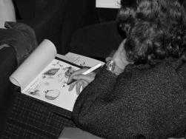

Fig. 1. A Brixen2003 participant taking notes during a lecture.

Do not add page numbers. Send the abstract via e-mail to firenze2024@gidrm.org. Thank you!

**References**

[1] E. M. Purcell, R. V. Pound, and N. Bloembergen *Phys. Rev.* **70**, 986-987 (1946)

[2] E. Hahn *Phys. Rev.* **80**, 580-594 (1950)